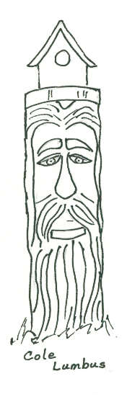
Wood Carvers, Whittlers, & Wood Crafters Festival Vendor & Exhibitor Packet

Application Submission Deadline: September 23, 2023

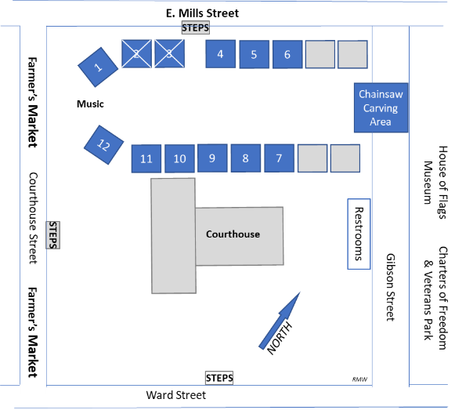
The Town of Columbus is a small community located on Highway 74 and I-26 in the Blue Ridge Mountain foothills of Western North Carolina. Columbus is the county seat and business/commerce center of Polk County. We are hosting a Wood Carvers, Whittlers, & Wood Crafters Festival on October 7th 2023. This annual festival continues to promise a unique fun-filled day with a wide variety of local and regional amateur and professional wood carvers, whittlers, turners, wood crafters and showing, selling, and giving demonstrations. This family friendly festival is scheduled on the historic Antebellum Courthouse lawn in conjunction with the Columbus Farmer’s Market on Courthouse Street. Local restaurants are nearby.

Festival Schedule
Saturday October 7, 2023, 9:00am to 2:00pm. (Set-up 8:00am to 9am)

Application Required
Only Wood Carvers, Whittlers, & Wood Crafters will be considered. All applications must be complete, signed, (pages 2 and 3 only) and payment submitted to be considered for approval. Vendor/Exhibitor applications are
due by September 23, 2023.

Questions? If you have any questions, please contact Ms. Ernie Kan at phone: 828-899-5111, email: erniekan@yahoo.com
See the “Events” page at: https://www.discovercolumbusnc.com/

Spaces: The Town of Columbus provides vendor/exhibitor spaces that are approximately 15’x 15’. All tents, trailers, tables, merchandise, and supplies MUST fit within this space. Additional spaces must be purchased if more room is required for your setup. Exhibit space locations (and options) may be requested and are assigned when completed applications are received and approved. See the exhibit area map above for proposed locations.

Electrical Connections: The Town Public Works Crew will be on hand from 8:00 AM – 9:00 AM to ensure electrical connections are available for exhibitors and vendors. Exhibitors and vendors are responsible for making sure their extension cords are of proper length, are properly plugged in and in safe working order.

Set-up and Take-down: Vendors/Exhibitors may set-up from 8:00 AM – 9:00 AM. All vehicles must be off the exhibit area and parked appropriately by 9:00 AM. No vendors may access the exhibit area with vehicles for loading until after 2:00 PM. All clean up should be completed by 3:00 PM.

Cleanliness and Final Clean-Up: All vendors are required to bring their own containers for garbage and recycling, as vendors will not be permitted to use the public containers for their refuse. All exhibitors/vendors must maintain his or her area in a clean and neat manner throughout the festival and complete a final clean-up prior to leaving the festival.

Arrival & Check-In: All vendors are required to access the festival area via Gibson Street. All Vendors/Exhibitors must stop to be checked in with festival staff upon arrival. If restocking is necessary during festival hours, traffic must flow to and from Gibson Street. Gibson Street will be the only way to accomplish that. Do not move or remove the traffic barriers in the festival area.

There is no designated parking for Vendor/Exhibitors. Parking in designated handicapped areas without appropriate handicapped placards is prohibited. Please find parking along Ward Street, Hampton Street, North Peak Street, or any adjoining lots that are not blocked off for private use.

In Case of Rain: In the case of rain or other inclement weather the event will be rescheduled to October 14th 2023.
Wood Carvers, Whittlers, & Wood Crafters Festival
Vendor & Exhibitor Application
Festival Date: Saturday October 7th 2023 - 9:00 am - 2:00pm

Application submission deadline: September 23, 2023

Organization/Individual Name Mailing Address ____________________________________________________________________
City ________________________________________________ State _____ Zip ___________________
Contact Name Phone
Email NC Sales Tax# (if applicable)
Web site (if applicable) _________________________________________________________________
Facebook page (if applicable) ____________________________________________________________
Payment MUST be included with your application. Cash, Check or Money Order Only will be accepted.

Booth Type  (All spaces are 15’x15’) | # of Spaces | Electricity Needed? Yes/No (Bring cords) | Fee per Space | Total Fee Enclosed | Payable to: Town of Columbus
☐ Craft Exhibitor (not selling) |  |  | $25.00
☐ Craft Vendor (selling) |  |  | $25.00

Check Needs: ☐ 110v Electricity ☐ 220v Electricity

Preferred Exhibit Space(s): _______________________________ if available. (See numbered spaces on first page map)

List ALL services offered, demonstrations, types of items to be sold, materials to be distributed, or items to be displayed:
(If not listed on application, cannot be sold at the festival) Use a separate sheet if necessary.
_______________________________________________________________________________________________
_______________________________________________________________________________________________
_______________________________________________________________________________________________
_______________________________________________________________________________________________

Liability Release and Acceptance of Conditions

I hereby release the Town of Columbus, Discover Columbus Committee, its employees, volunteers, officers and/or anyone else connected with the Event, of any and all known and unknown damages, injuries, and losses, judgments and/or claims from any causes whatsoever that may be suffered by anyone participating in this event.

I am aware that requesting a specific space does not guarantee the space will be granted, but the Town of Columbus (Discover Columbus Committee) will try to accommodate these requests as best they can. I understand that the Discover Columbus Committee representative will assign spaces as it deems appropriate, based on products to be sold and dates the application was received, and that the Town of Columbus (Discover Columbus Committee) reserves the right to refuse any vendor for any reason.

I understand that the Town of Columbus (Discover Columbus Committee) reserves the right to limit items to be sold as they see fit and agree to offer for sale only those items that are approved. I acknowledge there is no guarantee, expressed or implied, of success or failure of individual vendors at this event, and that I may only offer the items listed on my application for sale at the event.

I understand the event date is Saturday October 7, 2023. I understand that if I choose not to participate in the festival, I will not have my vendor/exhibitor fee refunded. No refunds of vendor/exhibitor fees will be made for any reason, without exception.

I certify that the information given in this application is true and accurate to the best of my knowledge.

By execution of this form, I certify that I have read and understand all rules and requirements set forth in this application packet, in its entirety, and that it is my responsibility as a vendor to ensure my application is complete and all requirements of participating in the festival are met. I further understand that I will not be permitted to set up at the festival or will be ejected from the festival if all requirements are not met or the conduct of myself or my agents is in violation of said regulations at any time.

Application submission deadline: September 23, 2023

Applicant’s Printed Name & Organization ________________________________________________________________

Applicant’s Signature _________________________________________________ Date__________________________

Mail completed Applications with payments to: E. Kan, PO Box 854, Columbus, NC 28722
OR
Deliver completed Applications with payment in person to: Town Hall at 95 Walker Street Columbus, NC

For Festival Use Only
Date Received: Complete: YES or NO Approved: YES or NO (Confirm with Vendor)
If not approved, reason:
Liability Release and Acceptance of Conditions signed and received? YES or NO (Confirm with Vendor)
Payment Information: ____________________________ Space Assignment: _____________________________

